1.2 Levels of Organization

1. **Molecular/chemical**: a molecule a cell
2. **Cellular**: a cell, cells are specialized
3. **Tissue**: group of same specialized cells
   1. **Epithelial**: cells specialized in exchange of materials, 2 types
      1. Epithelial sheets: skin, stomach linings…, serve as boundaries
      2. Secretary glands: endocrine vs exocrine
   2. **Muscle**: cells specialized for contracting; skeletal, cardiac, smooth
   3. **Nervous**: cells specialized for initiating and transmitting electrical impulses
   4. **Connective**: few cells dispersed in lots of extracellular material
4. **Organ**: 2 or more types of tissues together
5. **System**: groups of organs, 11 systems - circulatory, digestive, respiratory, urinary, skeletal, muscular, integumentary, immune, nervous, endocrine, and reproductive
6. Organism

1.3-1.4 **Homeostasis**

* Tendency towards a state of equilibrium, prevent extremes
  + Often controlled by different but interdependent organs
  + Temperature, pH, oxygen and CO2 concentration, water concentration, etc.
* **Intrinsic** (local to organ) vs **extrinsic** (whole body, involves other organs)
* **Feedback** vs **feedforward** (act on predicted future variables)
* **Negative feedback loop** (act in opposite direction, ex: oxygen, water, pH control) vs   
  **Positive feedback loop** (act in same direction, rare, ex: action potential, clotting)
  + **Controlled variable**: something to regulate
  + **Sensor/receptor**: detect change in the variable from its set point
    - Stimulus: movement of the system away from its set point
  + **Control center**: figure out what to do when the stimulus is detected
  + **Effector**: move variable back to normal
* Positive feedback loop must terminate with some distinct event
* Positive feedback can go out of control and result in pathology/pathophysiology

2.2 Cell Structure

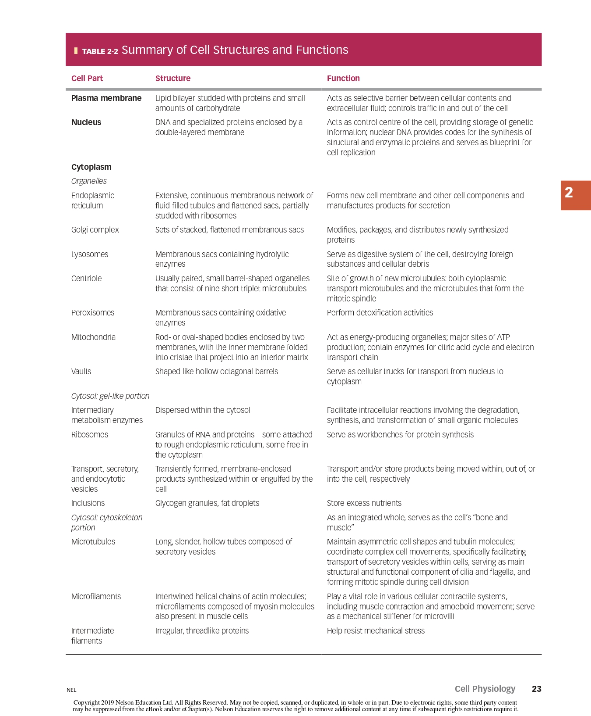

2.3 Cell metabolism (Introduction to the mitochondria and cellular structure)

* **Metabolism** (all energy related reactions in a cell) vs **catabolism** (releases energy by breaking molecules) vs **anabolism** (store energy by forming large molecules)
* **ATP**: adenosine triphosphate, the energy molecule for cells, releases lots of energy when the last phosphate group breaks off; Used for:
  + Synthesis of new chemical compounds, mostly protein
  + Membrane transport / selective transport
  + Mechanical work: contraction of muscle cells
* **Mitochondria**: where ATP is produced
  + Matrix: cavity, where pyruvate oxidation and Krebs cycle happen
  + Cristae: folds of the inner membrane, where electron transport chain happens
  + Intermembrane space: between inner and outer mitochondrial membrane, where the proton gradient builds up (mitochondria has double membrane like nucleus)
* **Electron carriers**: FADH2 (provides electrons for making 2 ATP) vs NADH (provides electrons for making 3 ATP)
* Diagram

  Description automatically generated**Phosphorylation**: combine phosphate to an organic compound, ex: formation of ATP from ADP
  + **Substrate-level** phosphorylation (glycolysis, Krebs cycle, creatine phosphate in muscles) vs **oxidative** phosphorylation (ETC in mitochondria)
* **Fermentation**: produce ATP only via glycolysis, doesn’t require oxygen (anaerobic)
  + temporary (need oxygen to re-oxidize NADH back to ${NAD}^{-}$), produce lactic acid (human) or ethanol (yeast/bacteria)
* **Cellular Respiration**: the ATP production process, 4 steps
  + **Glycolysis** (step 1): break down of glucose into 2 pyruvate / pyruvic acid
    - Occurs in the cytoplasm of cells
    - Produces 2 NADH and 2 ATP per glucose
  + **Pyruvate oxidation** (step 2): converts pyruvate molecules into acetyl-coA
    - occurs in the mitochondrial matrix
    - release 1 CO2 and produces 1 NADH per pyruvate (2 per glucose)
  + **Krebs / tricarboxylic acid / citric acid cycle** (step 3): breaks down acetyl-coA
    - Occurs in the matrix
    - Oxaloacetate is an intermediate molecule cycled (not consumed)
    - Releases 2 CO2 and produces 1 ATP, 3 NADH, 1 FADH2 per acetyl-coA
  + **Electron transport chain** (step 4): produces ATP via oxidative phosphorylation
    - Occurs in the inner mitochondrial membrane
    - Electrons from the carriers are passed on the protein complexes that uses this energy to pump protons into the intermembrane space
    - The proton gradient forces protons to go through ATP synthase, which uses this energy to produce ATP
      * 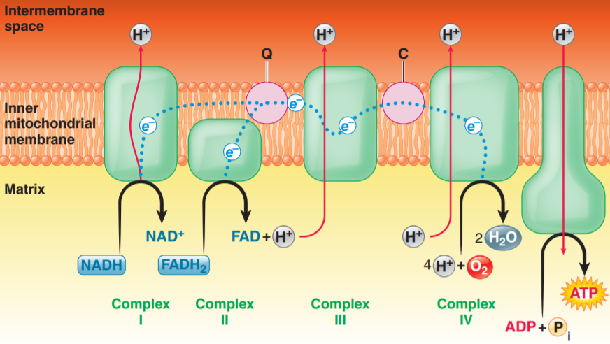1 NADH produces 3 ATP while 1 FADH2 only produces 2 ATP as FADH2 enters the chain later and activates less protons pumps
  + Total yield of ATP: theoretically 36-38, but actual numbers are around 30-32, ATPs are lost during the transport of electron carriers

2.4 – 2.5 Cellular membrane structure and adhesion

* **Fluid mosaic model**: model of the cell membrane with a phospholipid bilayer with proteins embedded and carbohydrates attached
* **Phospholipid bilayer**: two phospholipids tail to tail
  + **Phospholipid**: like triglyceride; phosphate head (**hydrophilic**) + 2 fatty acid chains with one of them bent (one or more double bonds, **hydrophobic**)
  + **Fluidity** of this layer decides how many molecules can diffuse in/out
    - The bent leg in phospholipid makes it less tight/more fluid
    - Increase in length of the fatty acid chains decreases fluidity
    - Increase in temperature increase the fluidity
    - **Cholesterol:** gets between phospholipids, prevents stacking thus increases fluidity; balances fluidity changes from temperature
  + **Semi-permeable:** Only allows small, uncharged, nonpolar molecules (generally hydrophobic molecules) to pass through freely with the exception of water
* **Proteins**:
  + Integral (embedded) vs peripheral (floats on the surface)
  + **Transport** substance through the phospholipid bilayer, **catalyze** reactions, **bind to signal molecules** like hormones, aid **cell adhesion**
* **Carbohydrates:** attached to the proteins / lipids to form glycoproteins / glycolipids, can be used for cells to **recognize** each other
* Adhesion techniques:
  + Biological glue (extracellular matrix (ECM)
  + Desmosomes (adhering junctions, involves adhesion molecules cell membranes)
  + Tight junctions (impermeable junctions)
  + **Gap junctions** (communicating junctions): gap between cells connected by connexons (six protein subunits arranged in a tube); allows small, water-soluble particles (ions) to be exchanged freely; ex: synchronous muscle contraction

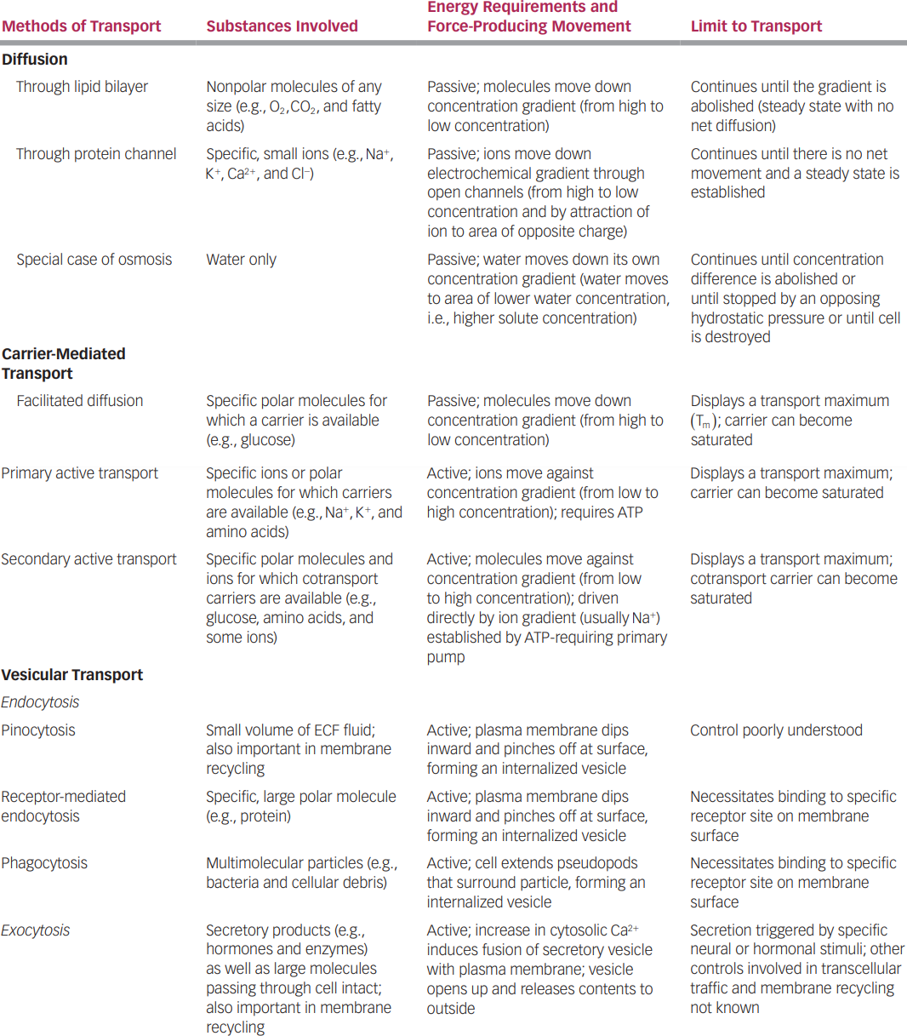2.6 – 2.8 Transport mechanisms

2.9 Intercellular communication & signal transduction

* Direct exchange of molecules through gap junctions
* Interactions provoked by surface identification markers (WBC)
* Specifically released extracellular chemical messengers bind with target cell receptors
  + **Paracrine**: distribute through diffusion, local / short distance, doesn’t enter blood stream, ex: histamine dilates blood vessels
  + **Neurotransmitters**: paracrine released by neurons (response to action potentials), also diffusion & local
  + **Hormones**: secreted into the blood by endocrine glands, long-range, only target cells of a particular hormone have receptors for it
  + **Neurohormones**: hormones released by neurosecretory neurons
* Ways of signal transduction
  + Lipid-soluble: diffuse in
  + Water-soluble: bind to receptors
  + Control membrane channels (open/close)
  + Signals second messenger inside cell
    - Fast synapse (alters channels directly) vs slow synapse (triggers second messengers, ex: serotonin)

2.10 Resting membrane potential

* **Membrane potential**: Electrical gradient inside vs outside across cell membrane, measured in millivolt (mV), negative potential means interior is more negative
  + Change in membrane potential requires the movement of ions across membrane, which generates an electrical current and vis versa, follows $V=IR$
* **Resting membrane potential**: constant membrane potential when the cells are not producing electrical signals
  + Primarily responsible ions: Na+, K+, anions (A−; large, negatively charged intercellular proteins)
  + Other important ions: Cl−, Ca2+
  + Table

    Description automatically generatedNa+, Cl−, Ca2+ in greater concentration out, K+ greater in, A‑ only in (impermeable)
    - **Sodium potassium pump**: 3 Na+ out,   
      2 K+ in, requires ATP
    - A− produced and stay inside
    - Membrane much more permeable to K+ than others
* **Equilibrium potential**: the membrane potential for a specific ion concentration such that the chemical and concentration gradient for that ion balances out (no net movement)
  + Text

    Description automatically generated−90 mV for K+, +60 mV for Na+, −70 mV for Cl−, +120 mV for Ca2+
  + Resting membrane potential is **−70 mV** controlled by percentage permeability of K+ & Na+, tend more towards K+’s equilibrium since it is more permeable
    - Not all ions matter! Only permeability of ions with set concentrations (controlled by the pumps) matter, other ions alter concentrations instead
    - Text

      Description automatically generatedEx: most cells don’t active transport Cl− but is highly permeable, the membrane potential determines its concentration / distribution, which is why it also has −70 mV equilibrium
* **Excitable tissues** (nerve and muscle): can rapidly change membrane potential (by altering membrane permeability to certain ions) to produce electrical signals
  + Diagram

    Description automatically generated with medium confidence**Polarization**: membrane has potential (not 0 mV); at resting potential membrane is polarized at −70 mV in a typical neuron
  + Generally, permeability is altered through (1) changes in electrical field (2) chemical messengers (3) stimulus (sound) (4) spontaneous change in potential
  + **Leak** (open all the time) vs **Gated** (open or closed) channels, gated can be **voltage**, **chemically**, **mechanically**, or **thermally** gated
* There are two basic forms of electrical signals: (1) **graded potentials**, which serve as short-distance signals; and (2) **action potentials**, which signal over long distances.

2.11 Graded potentials

* Slight change in membrane potential, often caused by opening Na channels
* Causes current and spreads to nearby areas **passively**, potential decreases with distance; signal can only travel **short distances**
* **No refractory period**, can lead to action potentials (which have refractory period)
* Ex: postsynaptic potentials, receptor potentials, end-plate potentials, pacemaker potentials, slow-wave potentials

2.12 Action potentials

* Brief, rapid, large changes in membrane potential
* Controlled by voltage-gated Na ad K channels
* Graphical user interface

  Description automatically generated with low confidenceDiagram

  Description automatically generated**Threshold potential**: all-of-none trigger, at threshold
  + (1) **rapid opening of Na activation gates**, Na enter => depolarization
    - Positive feedback loop
  + (2) **slow closing of Na inactivation gates**, halts Na entry after delay
    - Unlike variable duration of graded potential, the duration of an action potential is always the same in a give cell
  + (3) **slow opening of K gates**, K exits => repolarization and hyperpolarization
    - As potential returns, changing voltage shifts the Na channels to closed-but-capable-of-opening, ready to respond to another triggering event
    - K channels also close and the membrane channels returns to resting state
* **Restoration**
  + Long-term: Na-K pumps maintain the concentration gradients
  + Short-term: only about 1 out of 100 000 K & Na ions move, no need to restore
* 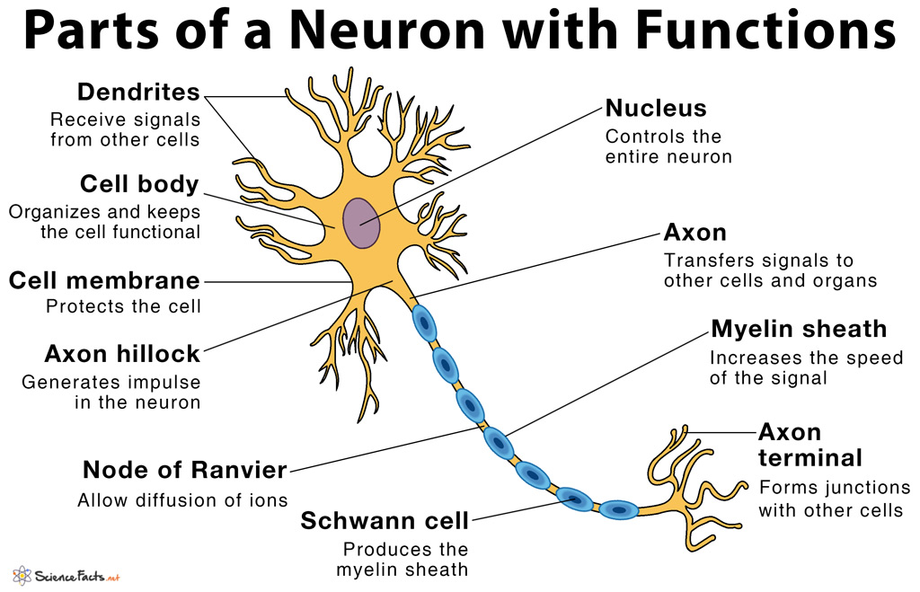**Neuron**
  + **Input zone**: dendrite and cell body; **trigger zone**: **axon hillock**, only place action potential can initiate; **conducting zone**: axon; **output zone**: axon terminal
  + Typically, regions of excitable cells where graded potentials take place do not undergo action potentials (sparse Na channels). However, graded potentials can, before dying out, trigger action potentials in adjacent portions of the membrane
  + Ex: graded potentials are generated in the dendrites and cell body in response to incoming chemical signals, (sufficient magnitude when they spread to the axon hillock) they initiate an action potential at triggering zone, and is conducted along the axon and passed on to another cell at the axon terminal
* **Propagation** (within one cell, between cells is synapse)
  + Within one cell – conducting zone, current spread passively to reach threshold of nearby areas, which then triggers Na channels
    - **Contiguous** (not myelinated) or **saltatory** (myelinated, channels concentrate at node of Ranvier, current “jumps”) conduction
    - one way only, **refractory period**: absolute (Na channels inactivated) vs relative (right after, Na channels capable but threshold hard to reach)
    - diameter & myelination effects speed
* Threshold is all-or-none, signal **strength determined by frequency** instead

2.14 Synapses and neuronal integration

* Diagram

  Description automatically generated**Synapses**: connection between two neurons, specifically between the axon of the presynaptic neuron and the dendrite / cell body of the postsynaptic neuron
  + **Synaptic cleft**: gap between the neurons, only 0.02 um but do not touch
  + **Synaptic knob**: contains synaptic vesicles
    - **Synaptic vesicles**: release neurotransmitters
    - **Calcium channels** open when the action potential arrives, let calcium ions into the cell (causes the release of synaptic vesicles)
  + **Neurotransmitters**: binding to receptor proteins on postsynaptic neuron that trigger ion channels and changes permeability (chemically gated!)
    - **Excitatory**: trigger Na and K channels, slightly depolarize the postsynaptic neuron so its closer to threshold (rarely directly triggers AP)
    - **Inhibitory**: trigger Cl or K channels, slight hyperpolarize the postsynaptic neuron so its further away from threshold
    - Can be both excitatory and inhibitory based on the receptor proteins
  + **Neuropeptides**: large molecules released in a similar way to neurotransmitters
    - **Neuromodulators**: doesn’t cause potential change but acts on the synapse (Ex. changes sensitivity to certain neurotransmitter)
  + After the transmission neurotransmitter are either diffused away, inactivated by enzymes, or reabsorbed by the presynaptic neuron
* **Grand postsynaptic potential** (GPSP): EPSP (excitatory postsynaptic potential) and IPSP (inhibitory postsynaptic potential) are additive, leading to GPSP and potentially AP
  + Table

    Description automatically generated**Temporal summation**: same place one after another (overlaps slightly each time)
  + **Spatial summation**: different places simultaneously
  + Up to 50 different summations can be required to trigger an action potential
* 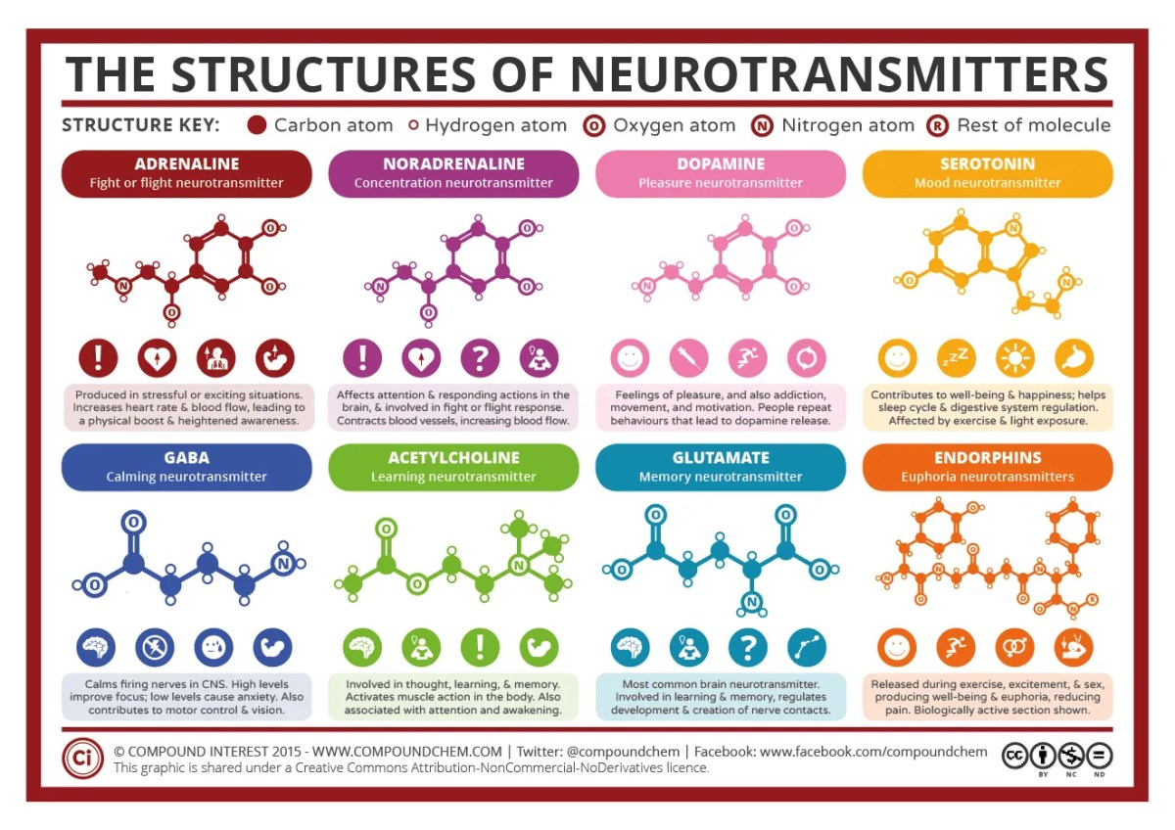Presynaptic facilitation / inhabitation: changes behaviour of presynaptic neuron (Ex. make less Ca enter)